**Institute of Technology Tralee**

**Computing Department**

**Object Oriented Programming 1**

**__________________________________________________**

**Session 1 – Java Console I/O and Calculations**

**(a)** Write a Java program that produces **exactly** the following output when it executes – try to **use just one println() statement** in your program and also use the **special characters** available in Java wherever possible. Also ensure that your program uses both types of **comment** at the top of the program. Note that the text “Press any key to continue…” appears automatically.

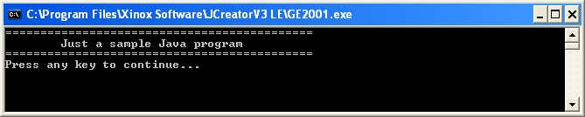

**(b)** Write Java initialisation statements which declare an integer variable called age whose initial value should be set to 10, a floating-point variable called height whose initial value should be set to 1.8m and a string variable called name whose initial value should be set to Joe Bloggs.

**(c)** Write a Java statement that will display the values of the variables referred to in the last question to the console window exactly as follows (use a single **println**() here)

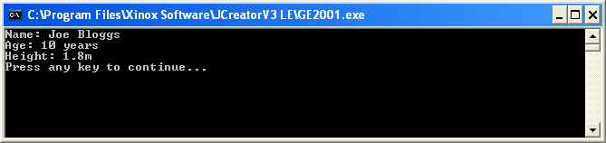

**(d)** Write a Java program that will read in the age of a person and display it back on the console. In this case you should make use of the Scanner class. You can take it that the age of the person will be entered as a **whole number** in this case. Your program would run as indicated in the following screenshot:

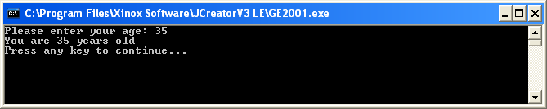

**(e)** Add to the program you have written in (d) so that after asking the user for their age, they are now also asked for their name, again using the Scanner class (be careful here!) This information should also end up getting displayed to the console. Your program would now run as indicated in the following screenshot:

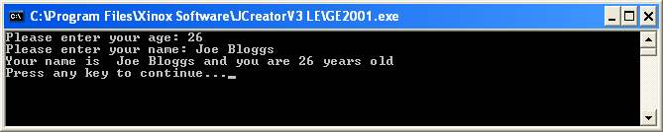

**(f)** Imagine that you have assigned integer variables called mathsMark, programmingMark, digitalImagingMark and webDesignMark the values 45, 64, 73 and 82 respectively. Write the Java code that could be used to display these variables neatly aligned, as indicated in the following screenshot:

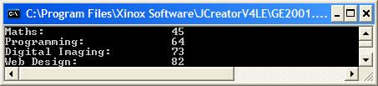

**(g)** In Java, what is the value of the expression 13/5 ?

**(h)** In Java, what is the value of the expression 17%3?

**(i)** In Java, what is the value of the expression 19 / 3 * 4 % 2

**(j)** Write the line of Java code that creates a single-precision floating-point constant called K and sets it to the value 22.56

**(k)** Write the line of Java code that creates an integer constant called MAX_LINES and sets it to the value 18

**(l)** Write a Java program that will read in values for 3 numbers (which could be fractional), determines their average and displays it to 3 decimal places as follows:

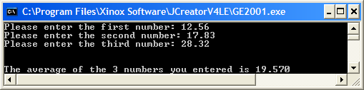

**(m)** Write a Java program that will read in a first number and then a second number (which will both be integers), and displays the value of

$$\frac{first number}{second number}$$

as both a decimal value, correct to 2 decimal places, and a percentage, to the nearest whole number. Your program would run as follows:

